  

**Centre Name: ACE – HCMC – 2 – FPT**

**Address: 590 Cach Mang Thang 8 Street – District 3 – Ho Chi Minh City - Vietnam**

Installation Guide

|  |  |  |
| --- | --- | --- |
| **Faculty:** | **Mrs. Le Mong Thuy** |  |
| **Batch No:** | **T1.2302.E1** |  |
| **Group No.:** | **01** |  |
| **Students:** | **Full Name** | **Roll No.** |
| 1. | NGÔ ĐÌNH TÂN |  |
| 2. | PHAN VĂN GIỮ |  |
| 3. | NGUYỄN THỊ NGỌC MAI |  |
| 4. | NGUYỄN THÀNH NHÂN |  |
|  |  |  |

28 DECEMBER, 2023

System Requirements

|  |  |
| --- | --- |
| **HARDWARE REQUIREMENTS** | |
| ***Minimum*** | |
| **ADMIN/ USERS** | * Intel core I7. * 8GB RAM. |
| ***Recommended*** | |
| **ADMIN/ USERS** | * Intel core I5. * 8GB RAM or higher. |
| **SOFTWARE REQUIREMENTS** | |
| **ADMIN/USERS** | * Microsoft® Windows 8/10/11. * XAMPP. * PHP MySQL. * Git Desktop. * Visual Studio Code |

# 1)Clone Project to computer

- Create and Open SEM2-Eproject

- Right Click and Select Open Git GUI here

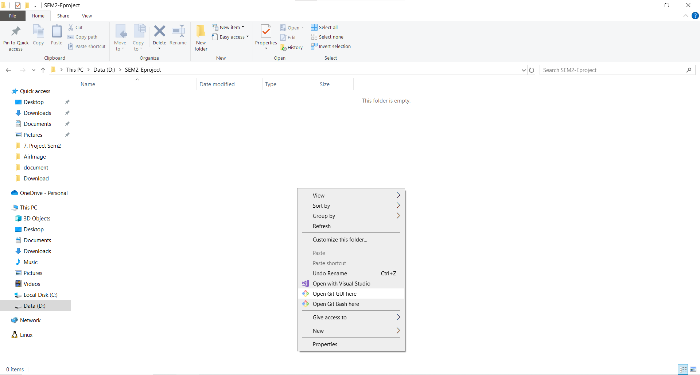

* When Git Gui open

1. In Source Location, copy and past <https://github.com/bigmouth3033/AirHouse-Sem2-Project.git>
2. In Target Directory, select where SEM2-Eproject' path created before and click Clone

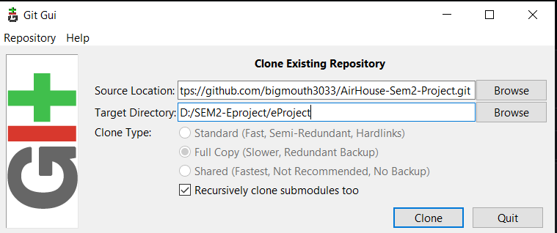

2) Install Composer Dependency and Node Dependency

* In Folder eProject -> open with Terminal -> input composer update
* 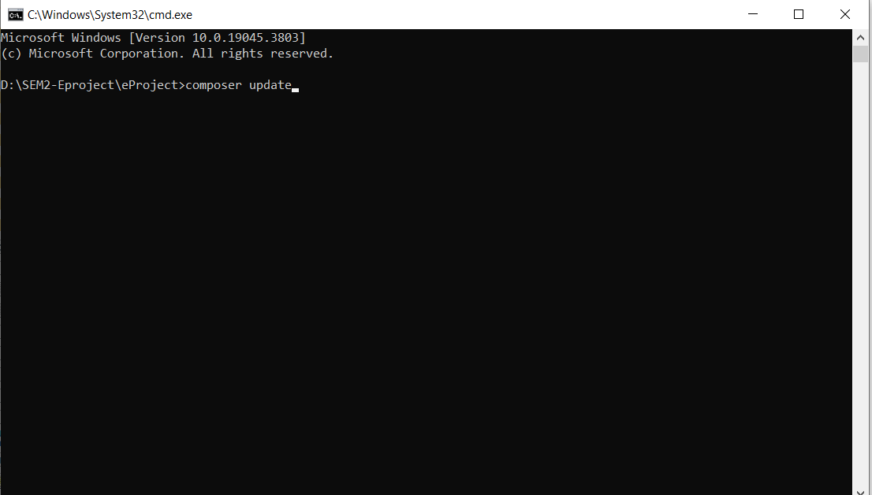
* Update Composer Dependency finish
* 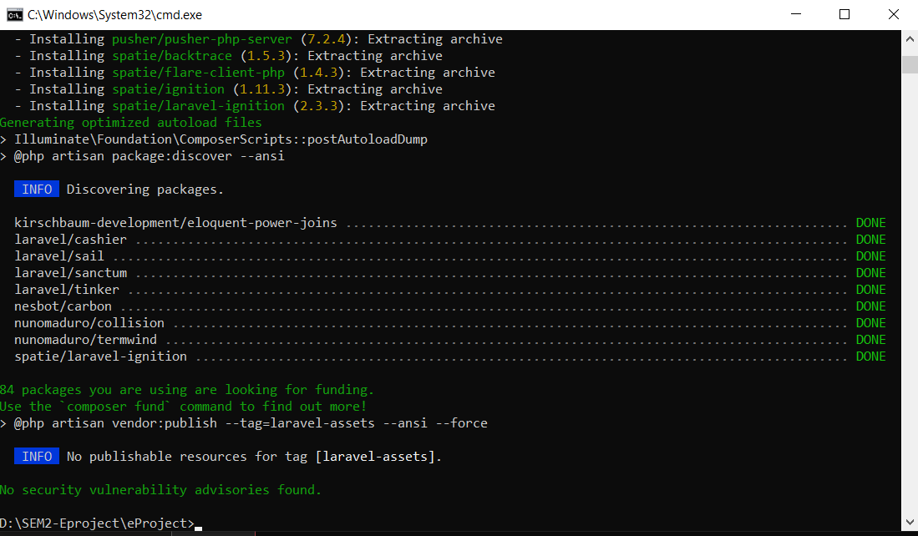
* In Folder eProject -> open with Terminal -> input cd AirHouseReact

- 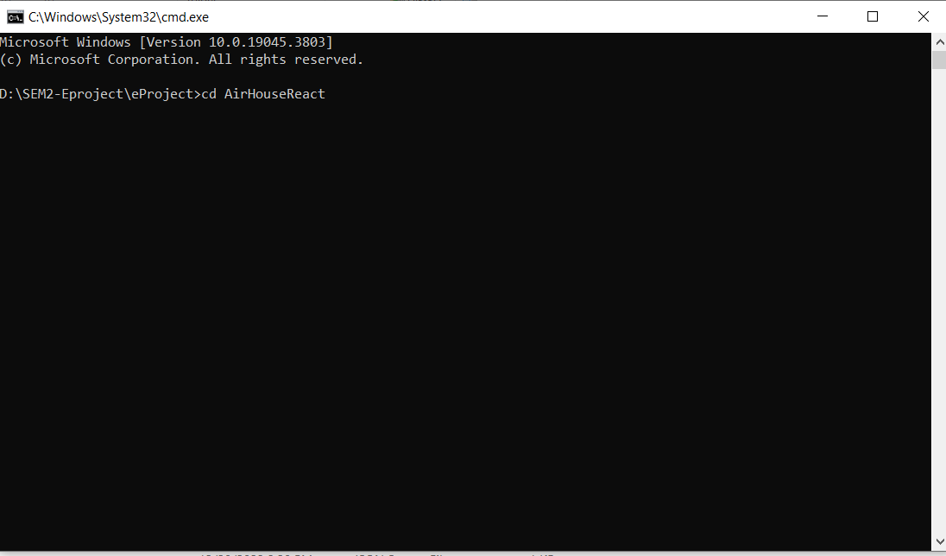

- input npm install and wait for a nofication

-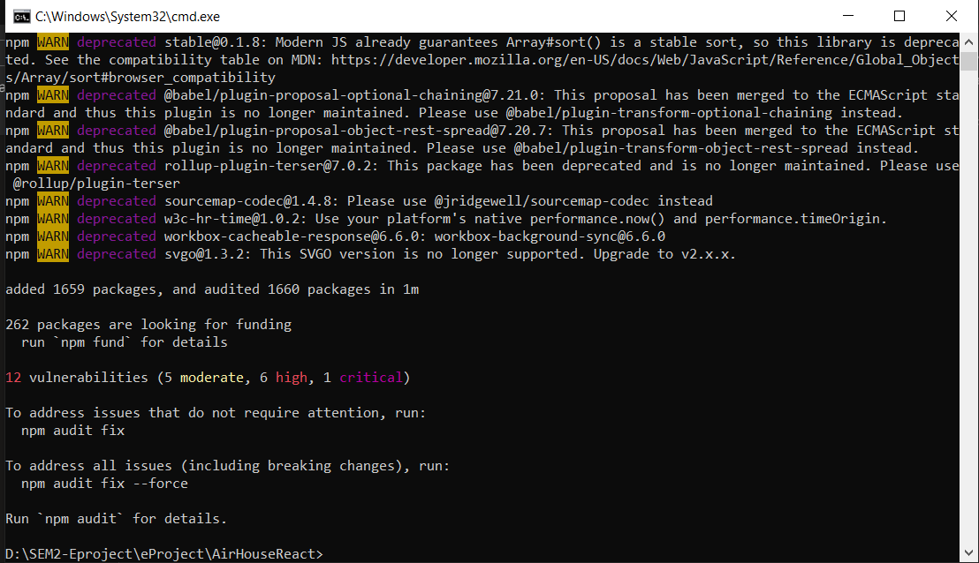

3) Import databse into XAMPP

* + Open **PHPMyAdmin**
  + Click **Import**

# Choose aptech_project.sql in your local folder

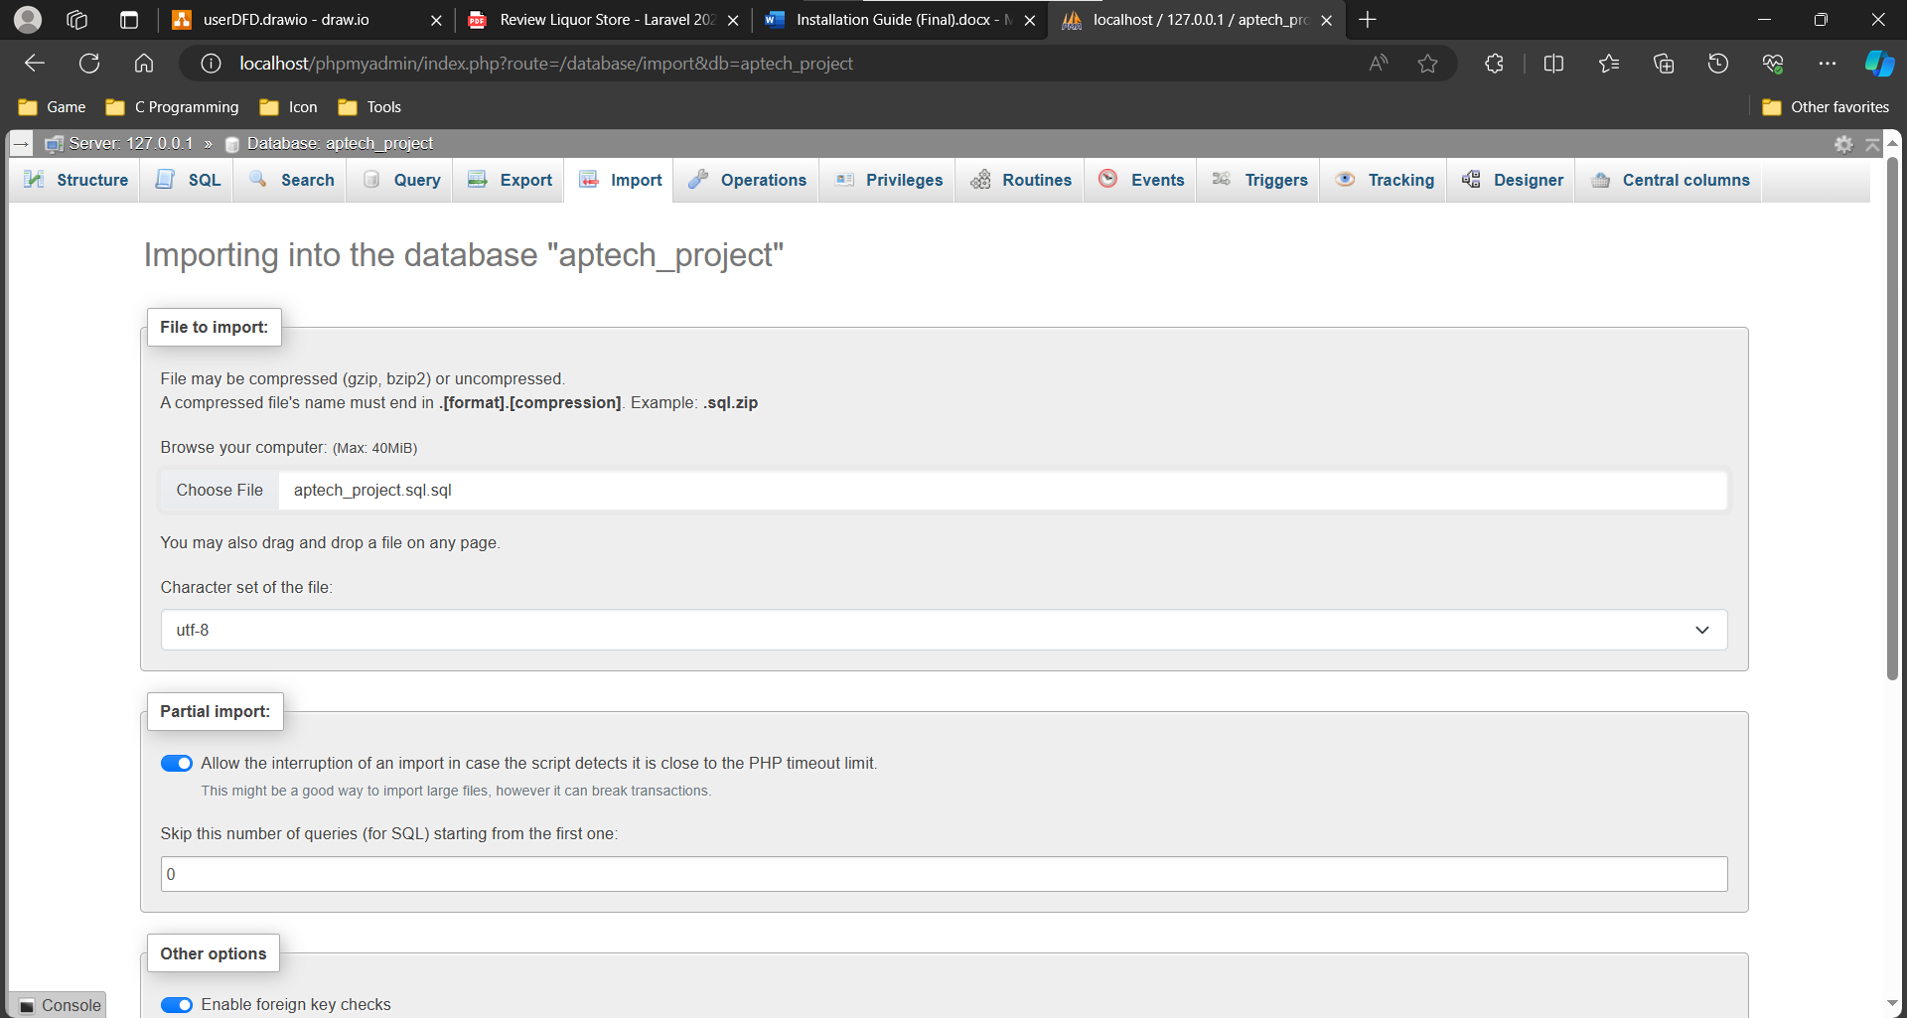

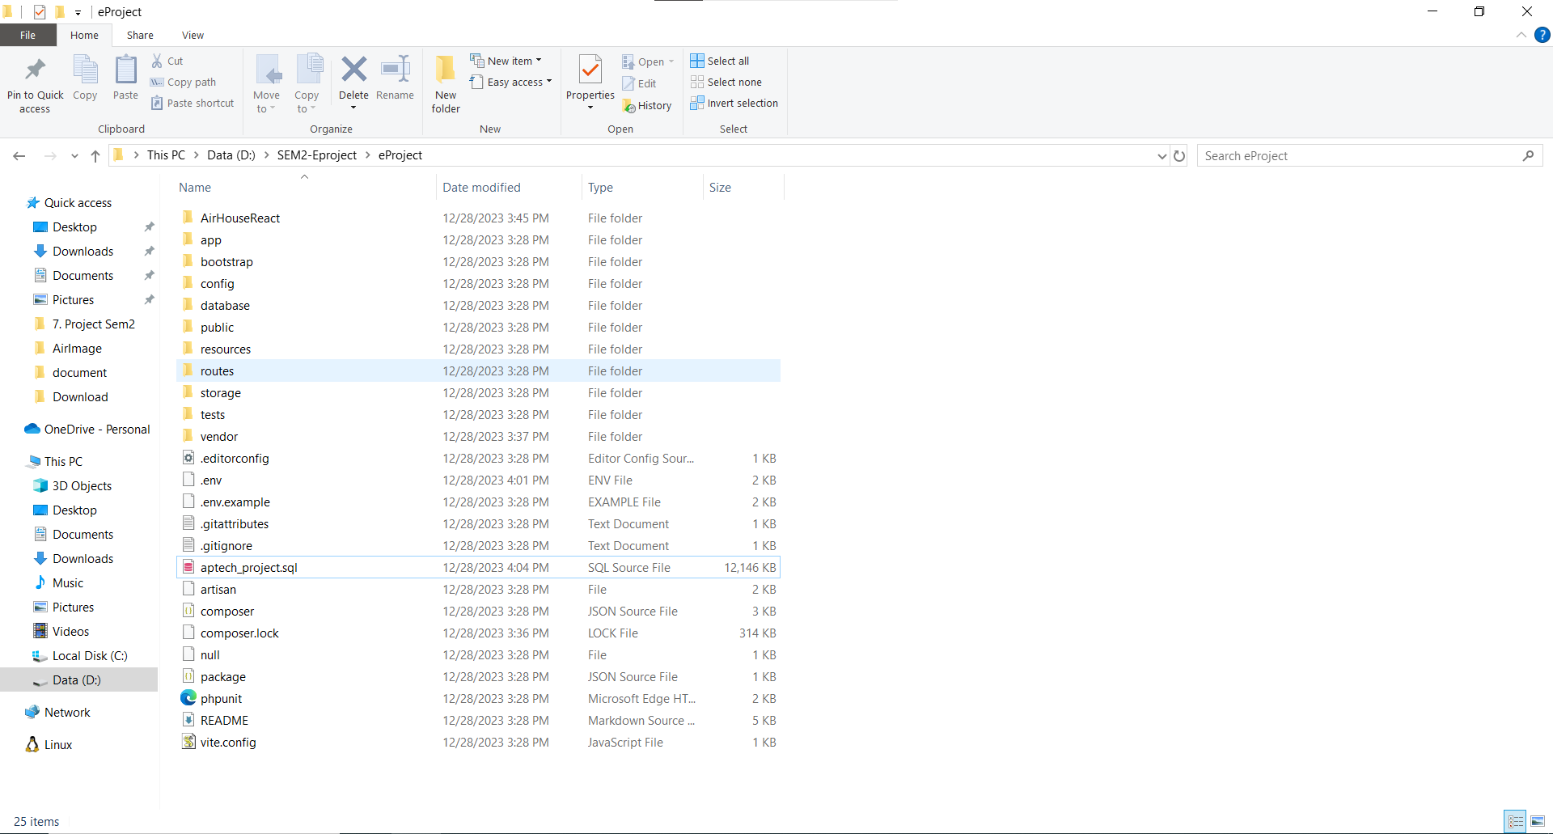

4) Run a Project

- In eProject folder -> Open with Terminal -> input php artisan serve

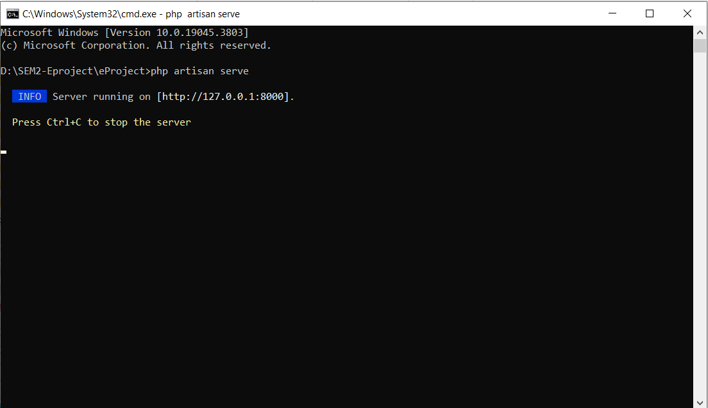

- In eProject folder -> Open with Terminal -> input cd AirHouseReact then input npm start

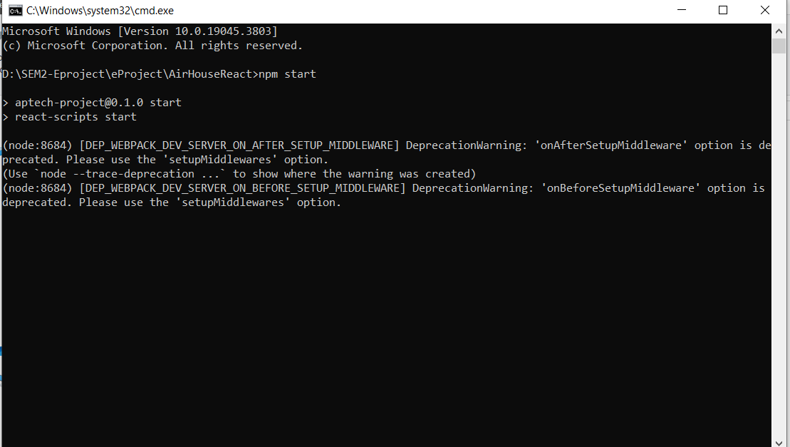

4) Enjoy the Website

